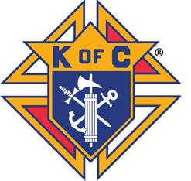

Holly Iben passed away in November 2023 leaving behind two children, Landon & Lianna. She was a kind-hearted person who always had a smile on her face and was willing to help anyone in need. The Monticello Knights of Columbus would like to honor her giving spirit by holding this benefit where all proceeds will go to her children.

**Please join us in supporting the family of Holly Iben while enjoying a good meal and fellowship!!**

Sponsored by Monticello Knights of Columbus

**Location: Newman Hall,**

**Basement of Sacred Heart Church**

**210 E 3rd Street, Monticello, IA 52310**

**Time: 4-8 pm**

**Cost: $10 adults/$5 kids**

**Serving Chili, Sandwiches, and Dessert**

**Chili Cook-off Details:**

**$10 Entry Fee**

Multiple Prizes to be awarded

**Enter by Sunday, February 25th to guarantee your spot!**

**To enter contest please contact:**

Ryan Sperfslage (319-480-3839)

Chili Cook-off Benefit

for the family of

Holly Iben

March 2, 2024